**ACTIVITY LOG FOR FIRST WEEK**

|  |  |  |  |
| --- | --- | --- | --- |
| **DAY**  **&**  **DATE** | **BRIEF DESCRIPTION OF THE DAILY ACTIVITY** | **LEARNING OUTCOME** | **Person**  **In-charge Signature** |
| Day-1 | Studied the guidelines of community service Project. | Understood the importance of Community Service Project. In the curriculum and got the Clear idea of the project. |  |
| Day-2 | I have selected the topic “UTILISATION OF ELECTRICITY TO FARMERS AND RELATED ISSUES” and started searching for a suitable place for the smooth conduct of the project. | The process helped me to easily select the suitable place for the project. |  |
| Day-3 | I went to nearby Sachivalayam for seeking permission for the smooth conduct of the project. | It helped me how to speak with higher officials. |  |
| Day-4 | I have surveyed some farmers about getting electricity. | Got the information about need of electricity in farming. |  |
| Day-5 | I spent time with the farmers and interacted about how much time they are getting electricity. | I got an idea about electricity provided for farmers. |  |
| Day-6 | We conducted a survey to know the details of farmers. | I found about the time they are spending in their farms and got to know about the usage of electricity. |  |

**WEEKLY REPORT**

**Week-1 (From dt: 13-05-2024 To dt: 18-05-2024)**

|  |
| --- |
| **Objective of the Activity Done: Utilisation of electricity to farmers and related issues***.* |
| **Detailed Report:** |
| On day-1:  In order to start the project   * Studied the guidelines of the project. * Understood the inclusion of Community Service project in the curriculum. * Pre-planned theWeek-1 schedule of the project. * Understood the changes come in the students behaviour after CSP.. |
| On day-2:   * I have selected the topic “UTILISATION OF ELECTRICITY TO FARMERS AND RELATED ISSUES”. * I have started searching the suitable place for my project. * In the process of selecting place, I came to know what are essential requirements required for selecting the suitable place for the project. |
| On day-3:  As a part of my project,   * I have visited nearby sachivalayam and met VRO. * Took permission from VRO for smooth conduct of my project. * I have explained him about my project. |
| On day-4:  I have surveyed some farmers and questioned them on utilisation of electricity to farmers:   * How much electricity is needed for a day? * Is electricity provided free? * Does free electricity come under government? |
| On day-5:   * I have observed the work done by the farmers on the field. * I started asking related question about providing electricity. * I got an idea about providing electricity to farmers. * I got the real time experience of farming. |
| On day-6:  As a part of final day of the week:   * I seeked an information about the need of electricity in villages to farmers. * I got an awareness how to interact with people. * I gained knowledge about our project and known how to interact with people. |

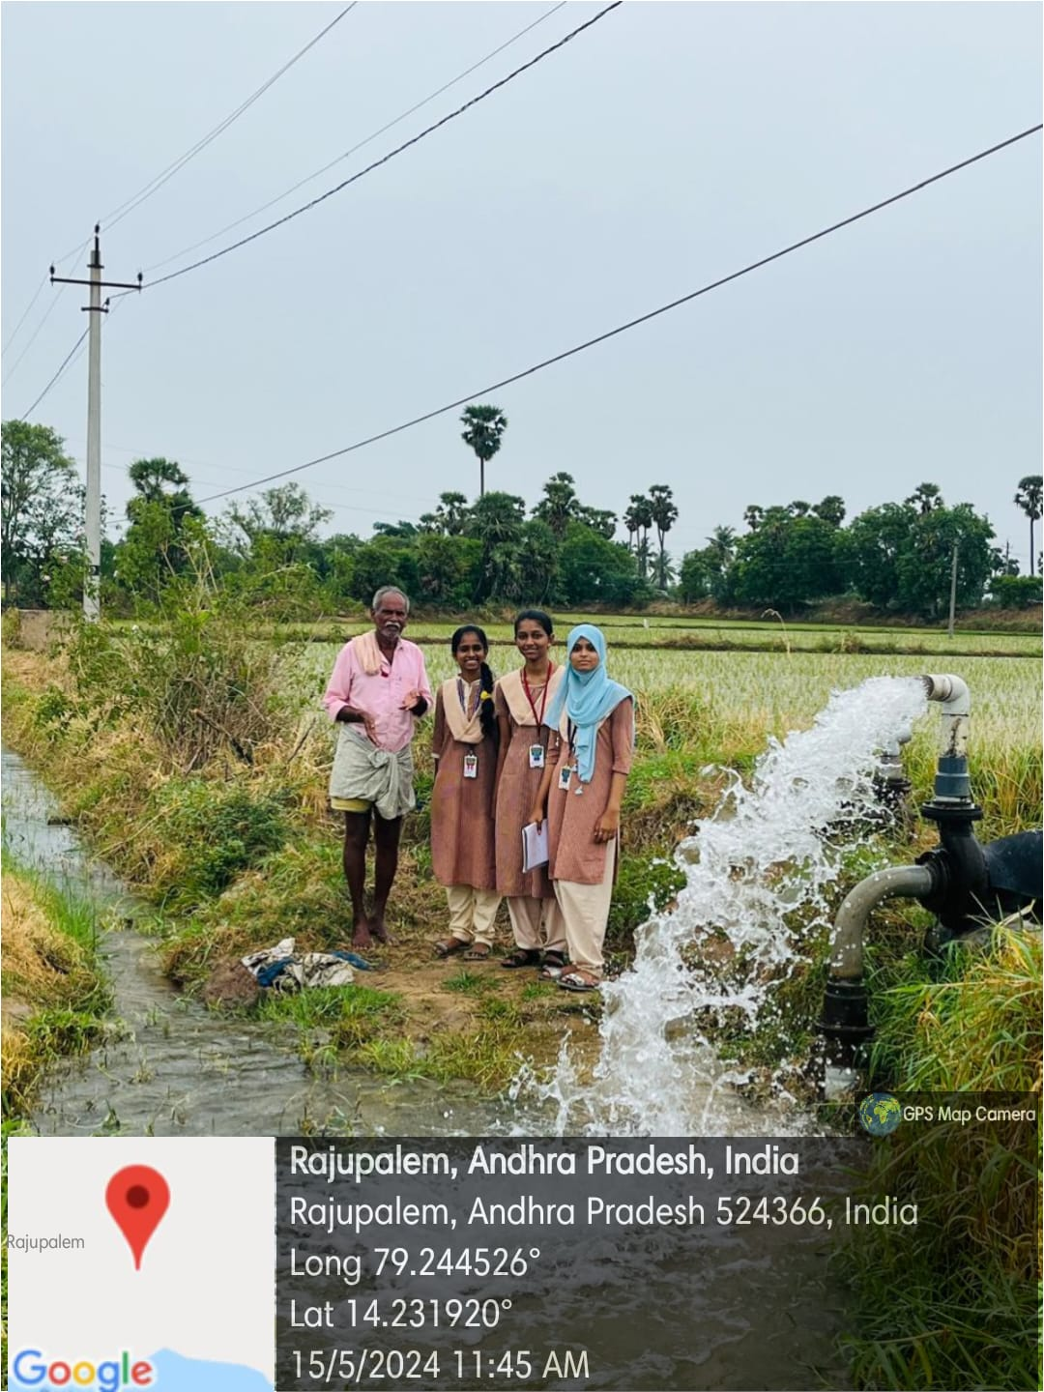

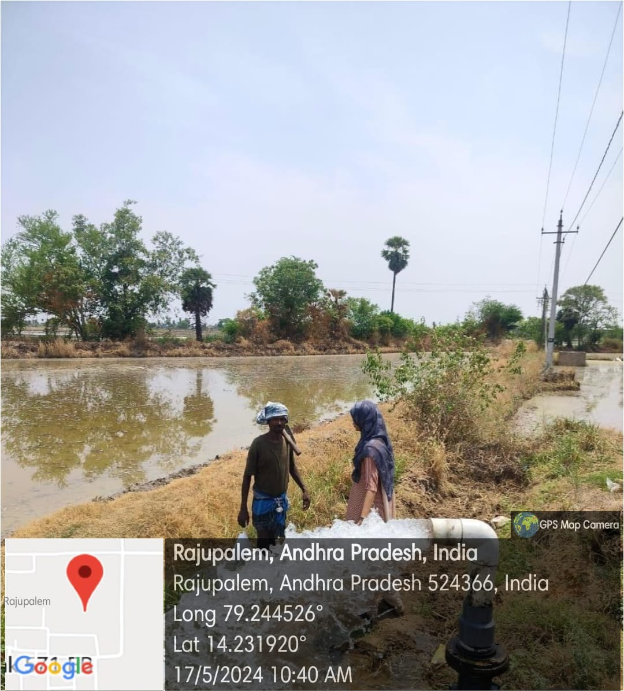

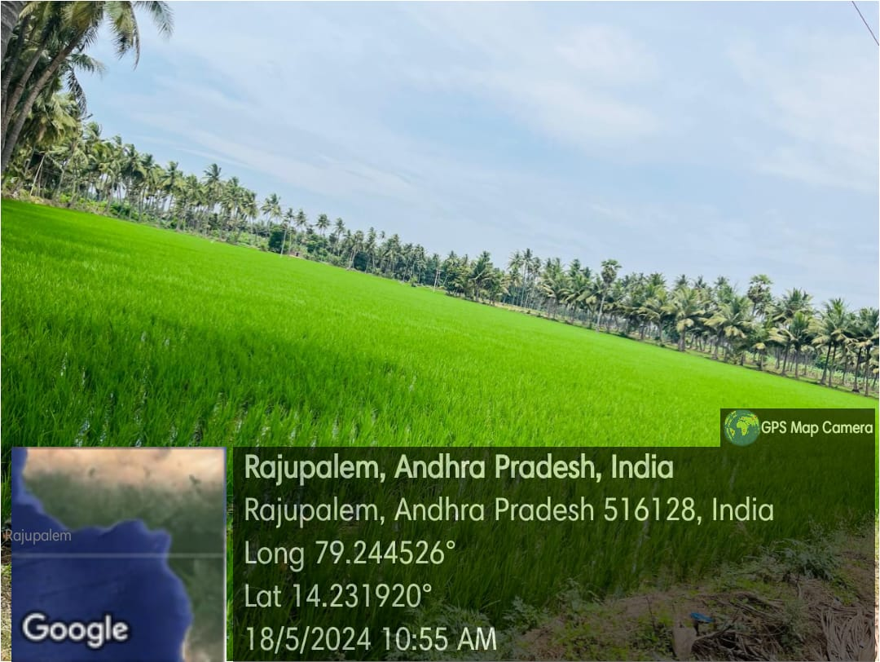

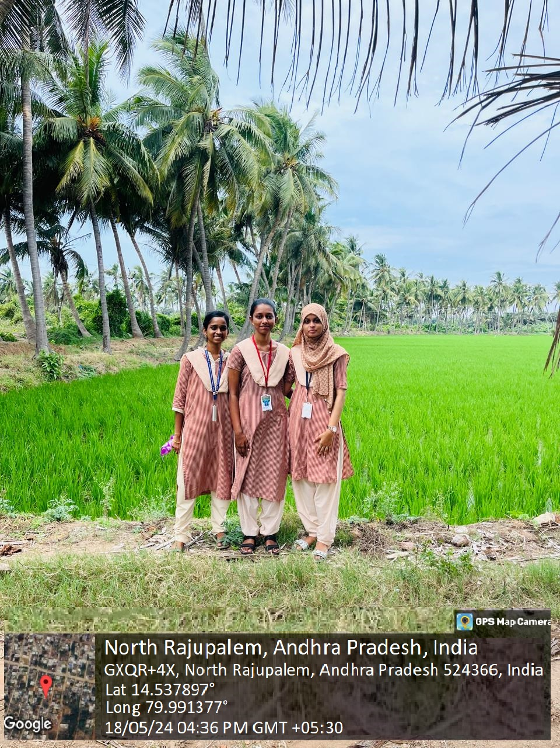

**ACTIVITY LOG FOR SECOND WEEK**

|  |  |  |  |
| --- | --- | --- | --- |
| **DAY**  **& DATE** | **BRIEF DESCRIPTION OF THE DAILY ACTIVITY** | **LEARNING OUTCOME** | **Person In-charge**  **Signature** |
| Day-1 | Visiting a village | We visited North Rajupalem, Nellore district to interact with people to know more. |  |
| Day-2 | Introduction of Electricity | Agriculture is the art and science of cultivating the soil, growing crops and raising livestock. |  |
| Day-3 | Uses of electricity in farming | >Motors  >Sprinkle Irrigation  >Drip irrigation |  |
| Day-4 | Usage of motor | The motors are used to power a variety of machinery, including plowing, tilling, and harvesting equipment. |  |
| Day-5 | Usage of electricity in a day | On an average a village called Rajupalem has a total electricity  demand of approximately 1,826 kWh per day. |  |
| Day-6 | Importance of electricity for a particular crop | Paddy fields require consistent water supply for optimal growth. Electric pumps and tube wells powered by electricity facilitate efficient irrigation, ensuring that  the crop receives adequate water throughout its growth cycle. |  |

**WEEKLY REPORT**

**Week-2 (From dt: 20-05-2024 To dt: 25-05-2024)**

|  |
| --- |
| **Objective of the Activity Done: Utilization of free electricity to farmers and related issues***.* |
| **Detailed Report:** |
| On day-1:   * On this day our team visited Rajupalem in the Nellore district and conducted survey. * The village is known for its traditional farming practices. * We identified area is fertile and well-suited for growing a variety of crops due to the favorable climatic conditions. |
| On day-2:   * We then started to know about farming and conditions that they grow. * We observed, farming in Rajupalem is characterized by a mix of traditional and modern agricultural practices. * We observed the fertile soils and favorable climatic conditions make Rajupalem an   ideal location for diverse agricultural activities. |
| On day-3:   * We asked them how they use electricity for their purposes. * We came to know, some farmers use electricity for drip and sprinkler irrigation. * And electric threshers to separate grains from the harvested crops, saving time and labor. |
| On day-4:   * We noticed motors are critical component in modern farming. * We questioned them regarding usage of motors. * Motors are extensively used to power electric water pumps, which draw water from wells, canals, and tanks to irrigate fields. |
| On day-5:   * We surveyed how often they use electricity for a day. * We gathered information is that, electricity is good for one time a day and not for another time. |
| On day-6:   * We observed mostly that, paddy is the most common growing crop in Rajupalem. * For this they use electric water pumps, drip and sprinkler systems in giving most importance to electricity * And finally, we submitted this week report to our respected guide. |

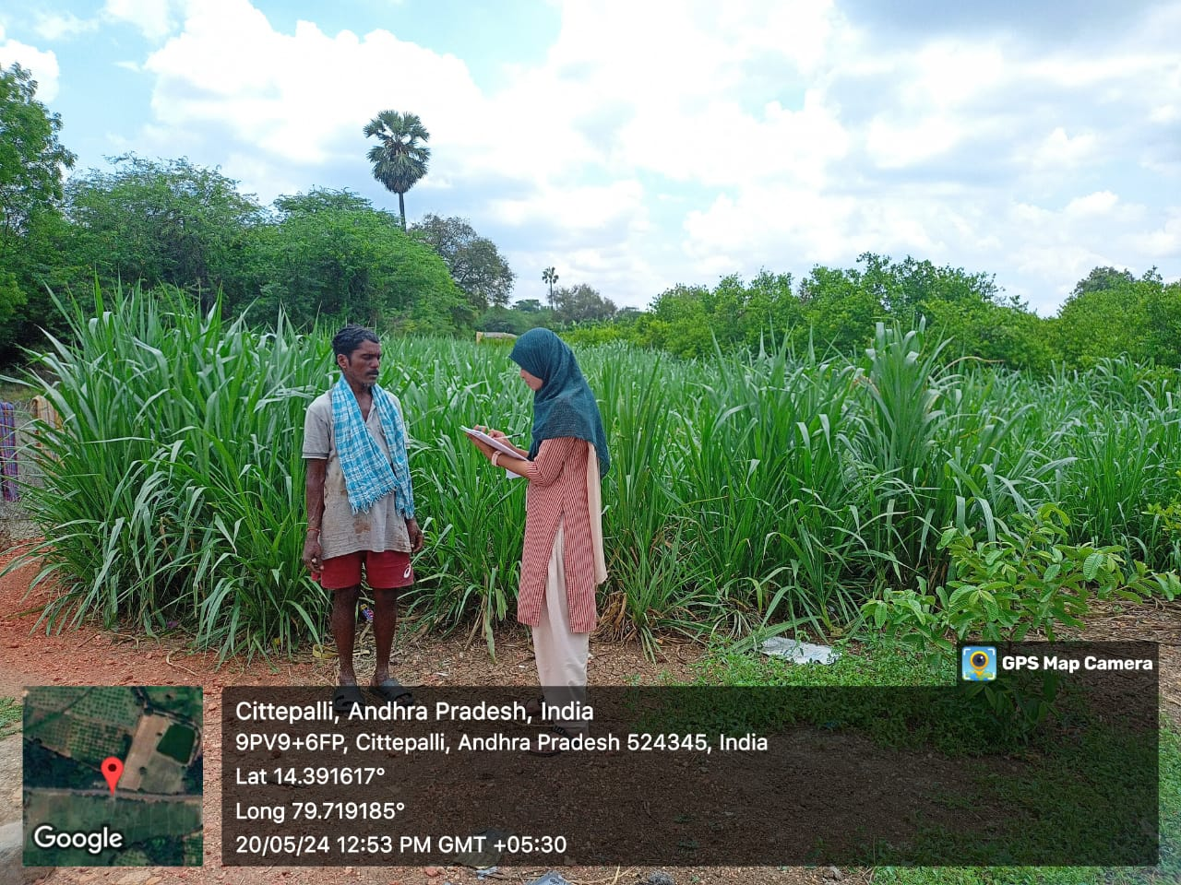

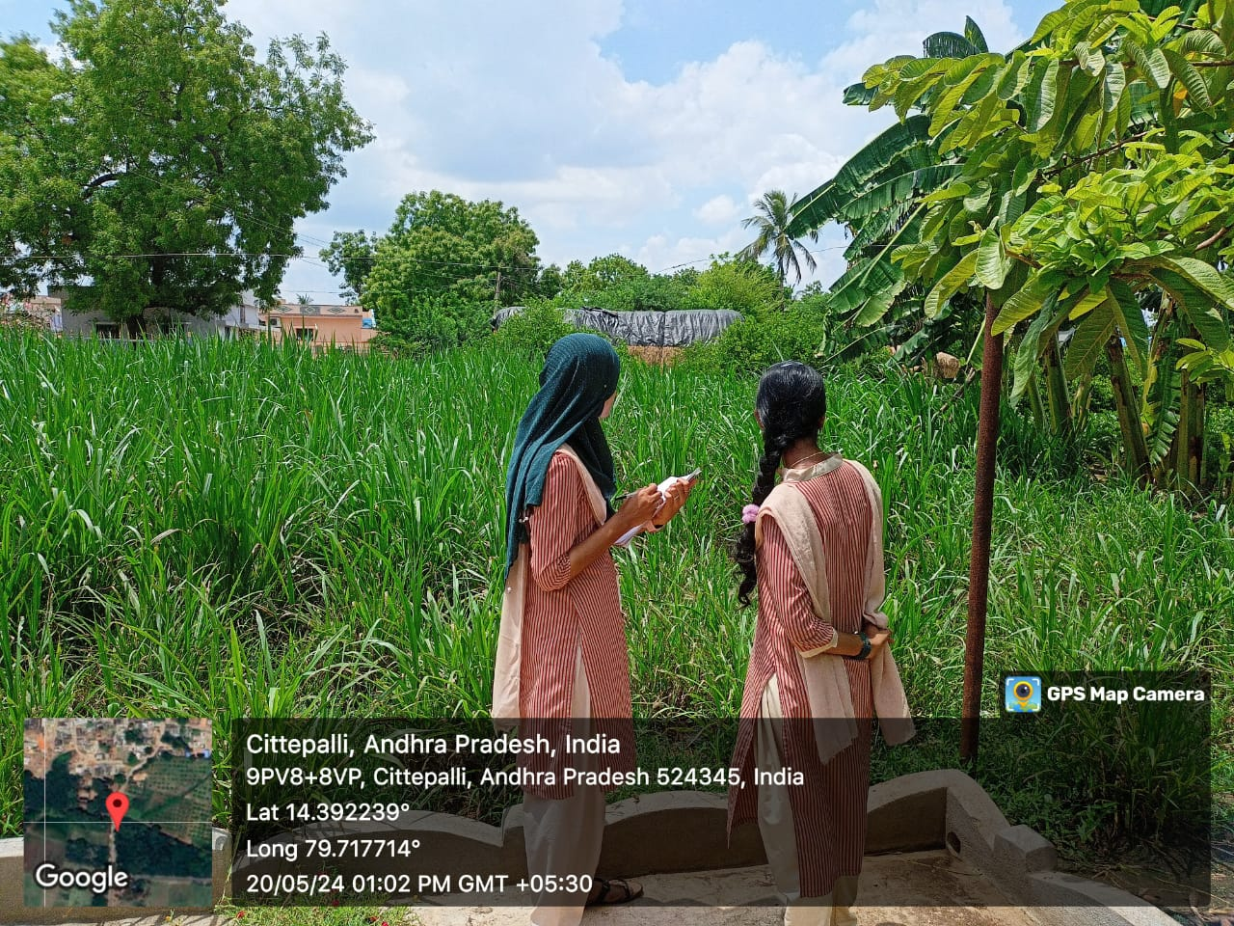

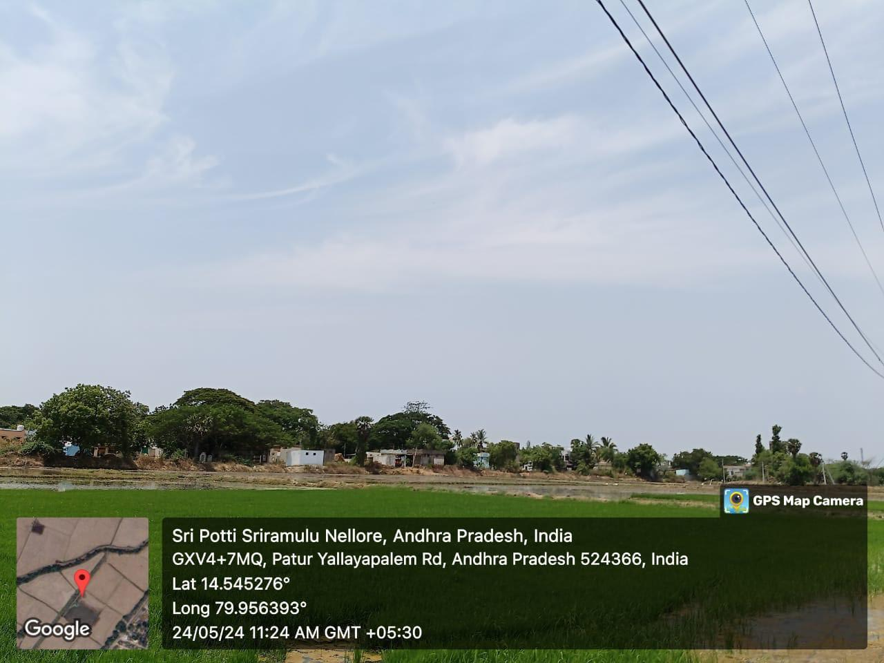

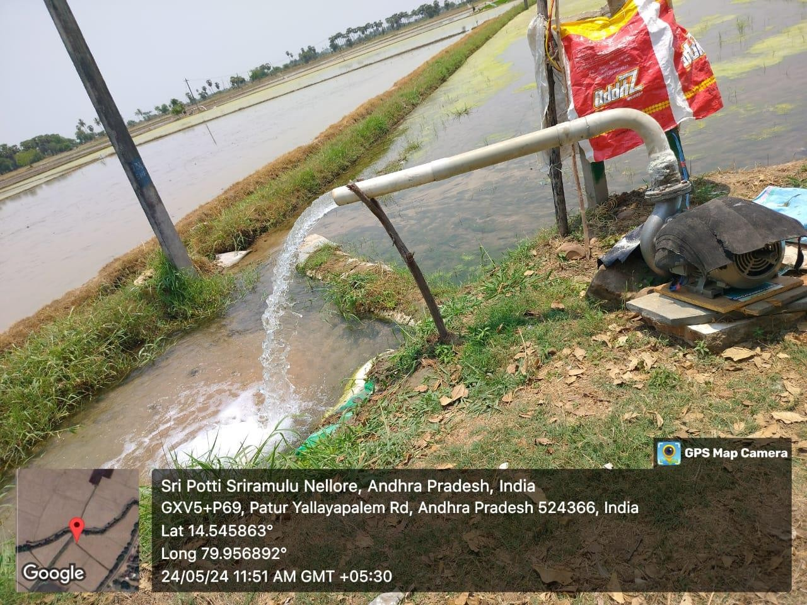

*Motors in Village Rajupalem*

**ACTIVITY LOG FOR THIRD WEEK**

|  |  |  |  |
| --- | --- | --- | --- |
| **DAY**  **& DATE** | **BRIEF DESCRIPTION OF THE DAILY ACTIVITY** | **LEARNING OUTCOME** | **Person**  **In-charge**  **Signature** |
| Day-1 | Visiting a village | We visited Mypadu(4th mile), Nellore district to interact with people to know more. |  |
| Day-2 | Introduction to Solar panels and cost of a Solar panel | Solar panel systems can bring many advantages to rural villages, including **improved access to electricity, reduced energy costs, and economic opportunities.**  The average cost of a solar panel in the  U.S. ranges  between **$17,350** and **$38,000**, depending on location. |  |
| Day-3 | Advantages of Solar panels | * Reduction of Electricity Bills * Low Maintenance * Environmentally Friendly * Job Creation |  |
| Day-4 | Crops grown under Solar panels | -Leafy green vegetables like cabbage and broccoli  -Berries like strawberries, blueberries  -Root vegetables |  |
| Day-5 | Factors influencing Solar panels | >Climatic conditions  >Location and orientation  >Temperature  >Weather conditions  >Inverter efficiency |  |
| Day-6 | Conclusion | We finally understood about solar panels by interacting more we known about what crop can be cultivated and advantages of solar panels. |  |

**WEEKLY REPORT**

**Week-3 (From dt: 27-05-2024 to dt: 01-06-2024**)

|  |
| --- |
| **Objective of the Activity Done: Utilization of free electricity to farmers and related issues***.* |
| **Detailed Report:** |
| On day-1:   * On this day our team visited 4th mile in the Nellore district and conducted survey. * The fields growing here are very vast in area and greenery finds everywhere. * And started asking people about their way of growing. |
| On day-2:   * After conversation with farmers, we came to know that solar panels systems are somewhere used. * Farmers can generate electricity for their own purposes i.e., water motors. * Average cost ranges from Rs.35,000 to Rs.55,000 for installation. |
| On day-3:   * We questioned them what advantages are by solar panels. * We understand that it reduces electricity usage, eco-friendly, easy maintenance. |
| On day-4:   * We asked what type of crops are grown by using solar panels. * They said,” We grow leafy vegetables, cabbage, root vegetables.” |
| On day-5:   * We surveyed about factors that influence solar is: * Climatic conditions, temperature, weather conditions, location. * We came to conclusion of usage of solar panels and profit for the farmers |
| On day-6:   * We finally understood that, the working of solar panels, their cost and type of crops grown and factors. * And finally, we submitted this week report to our respected guide. |

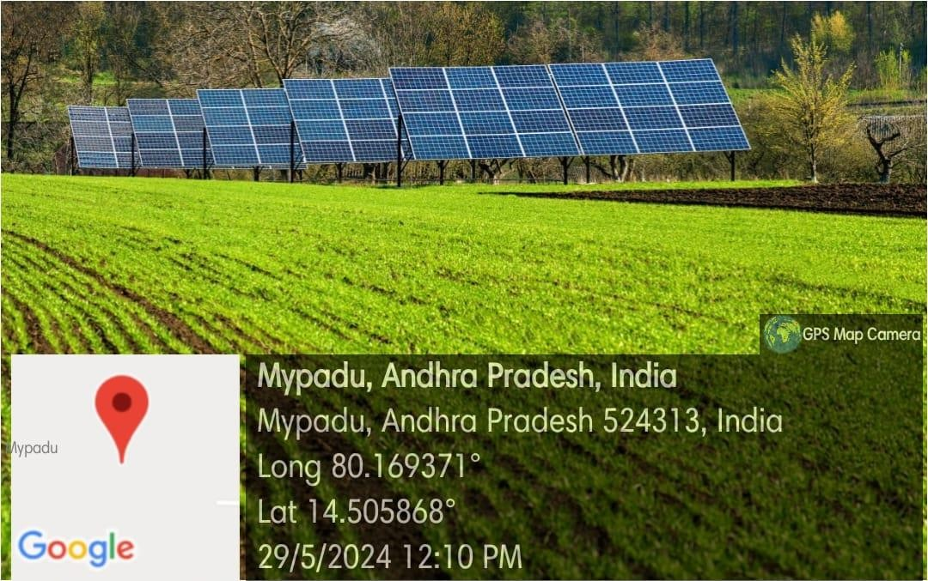

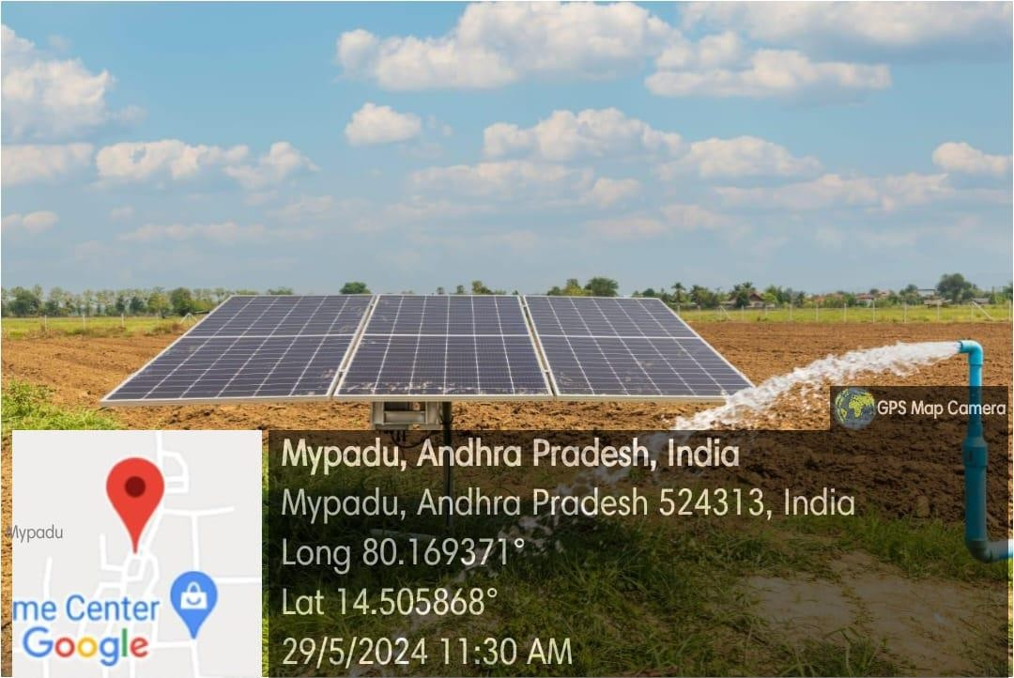

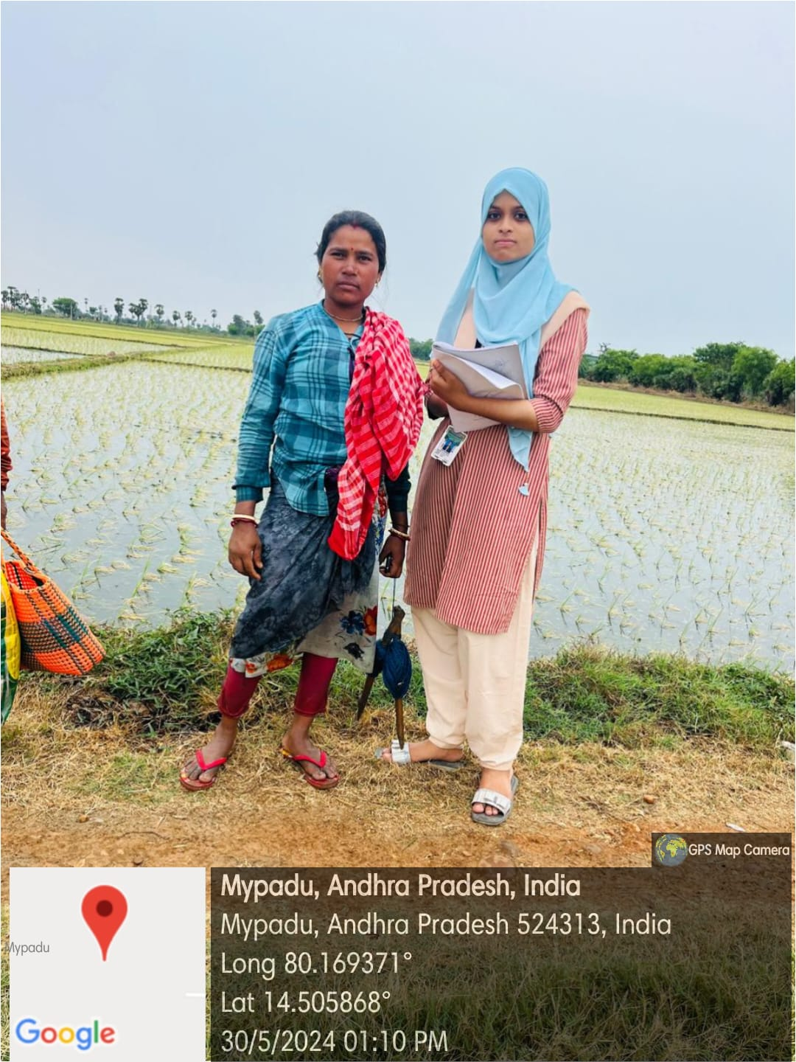

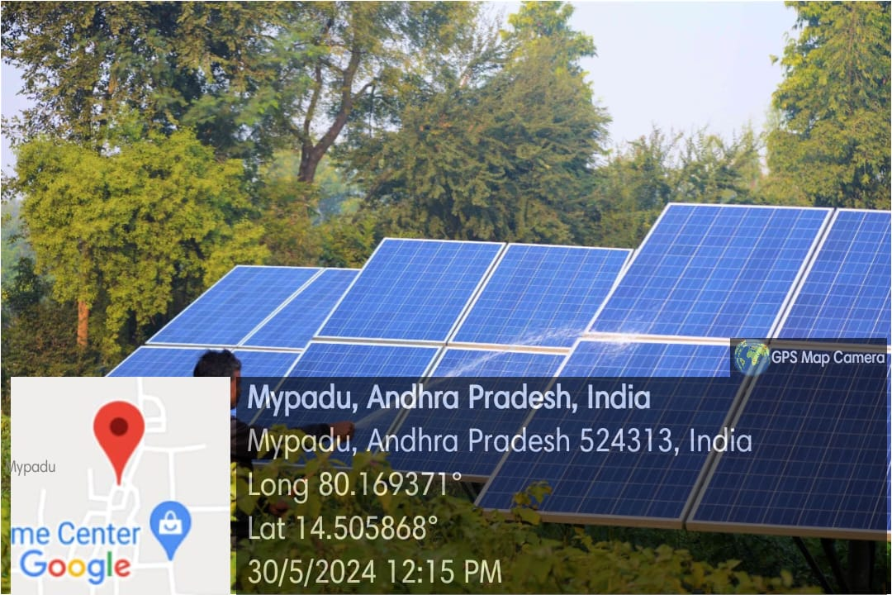*Solar panels*

**ACTIVITY LOG FOR FOURTH WEEK**

|  |  |  |  |
| --- | --- | --- | --- |
| **DAY & DATE** | **BRIEF DESCRIPTION OF THE DAILY ACTIVITY** | **LEARNING OUTCOME** | **Person In-charge Signature** |
| Day-1 | What is Drip irrigation? | Drip irrigation, also known as trickle irrigation or micro-irrigation, is a **precision water delivery system** designed to save water and nutrients. |  |
| Day-2 | How does Drip irrigation work? | It works based on few categories:  >Tubing and emitters  >Efficient water use  >Crop types  >Water source |  |
| Day-3 | What are the advantages of using Drip irrigation? | ✧Increased plant health  ✧Money savings  ✧Energy savings  ✧Water conservation and efficiency |  |
| Day-4 | What are the disadvantages of Drip irrigation? | >Direct sunlight reduces lifespan of tubes.  >Affects soil fertility  >Root growth restriction  >Improper filtration may cause clogging |  |
| Day-5 | Types of Drip irrigation? | ✧Point source emitter system  ✧Inline drip system  ✧Subsurface drip system  ✧Drip tape system  ✧Micro-sprinkler system |  |
| Day-6 | What types of crops are best suited for Drip irrigation? | >Vegetables: Tomato, Onion, Bitter gourd  >Cash crops: Sugar cane, Cotton  >Orchard crops: Grapes, Banana, pomegranate, Citrus |  |

**WEEKLY REPORT**

**Week-4 (From dt: 03-06-2024 to dt: 08-06-2024)**

|  |
| --- |
| **Objective of the Activity Done: Utilization of free electricity to farmers and related issues***.* |
| **Detailed Report:** |
| On day-1:   * On the day of our survey, we got to know an irrigation method called ‘Drip irrigation’. * We prepared survey questionnaire, and initial questions on drip irrigation. |
| On day-2:   * We learnt how drip irrigation works. It works based on many categories. * Some are tubing and emitters, water source, crop types. * In this method, water is supplied directly through roots. |
| On day-3:   * After knowing all these, we surveyed abut its advantages. * Like- Energy savings, increased plant health, money savings. |
| On day-4:   * All can’t be good, so we surveyed also about its disadvantages. * It reduces life span of tube due to direct sunlight, sometimes water may not be distributed evenly to crops. |
| On day-5:   * Drip irrigation includes in different types for different crops and farming practices. * Micro sprinkler for large areas, Inline drip for row crops and gardens, subsurface drip for crops that grow under surface. |
| On day-6:   * At last we are interested in knowing which crops are growing under this system. * They are vegetables like tomato, onion. Cash crops like sugarcane, cotton and more like grapes, banana, etc. |

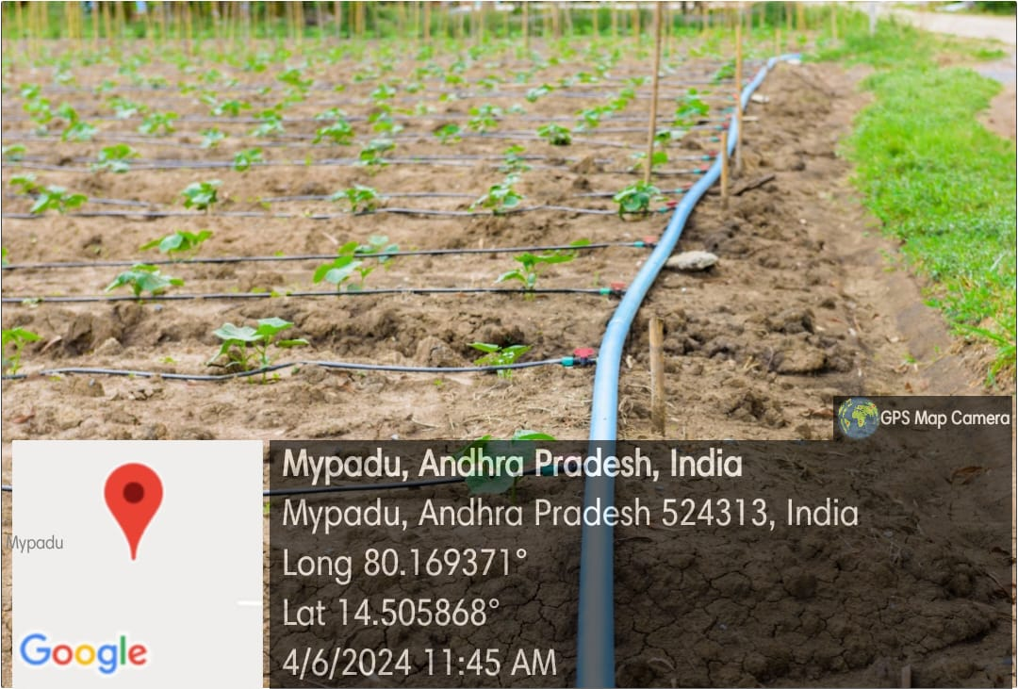

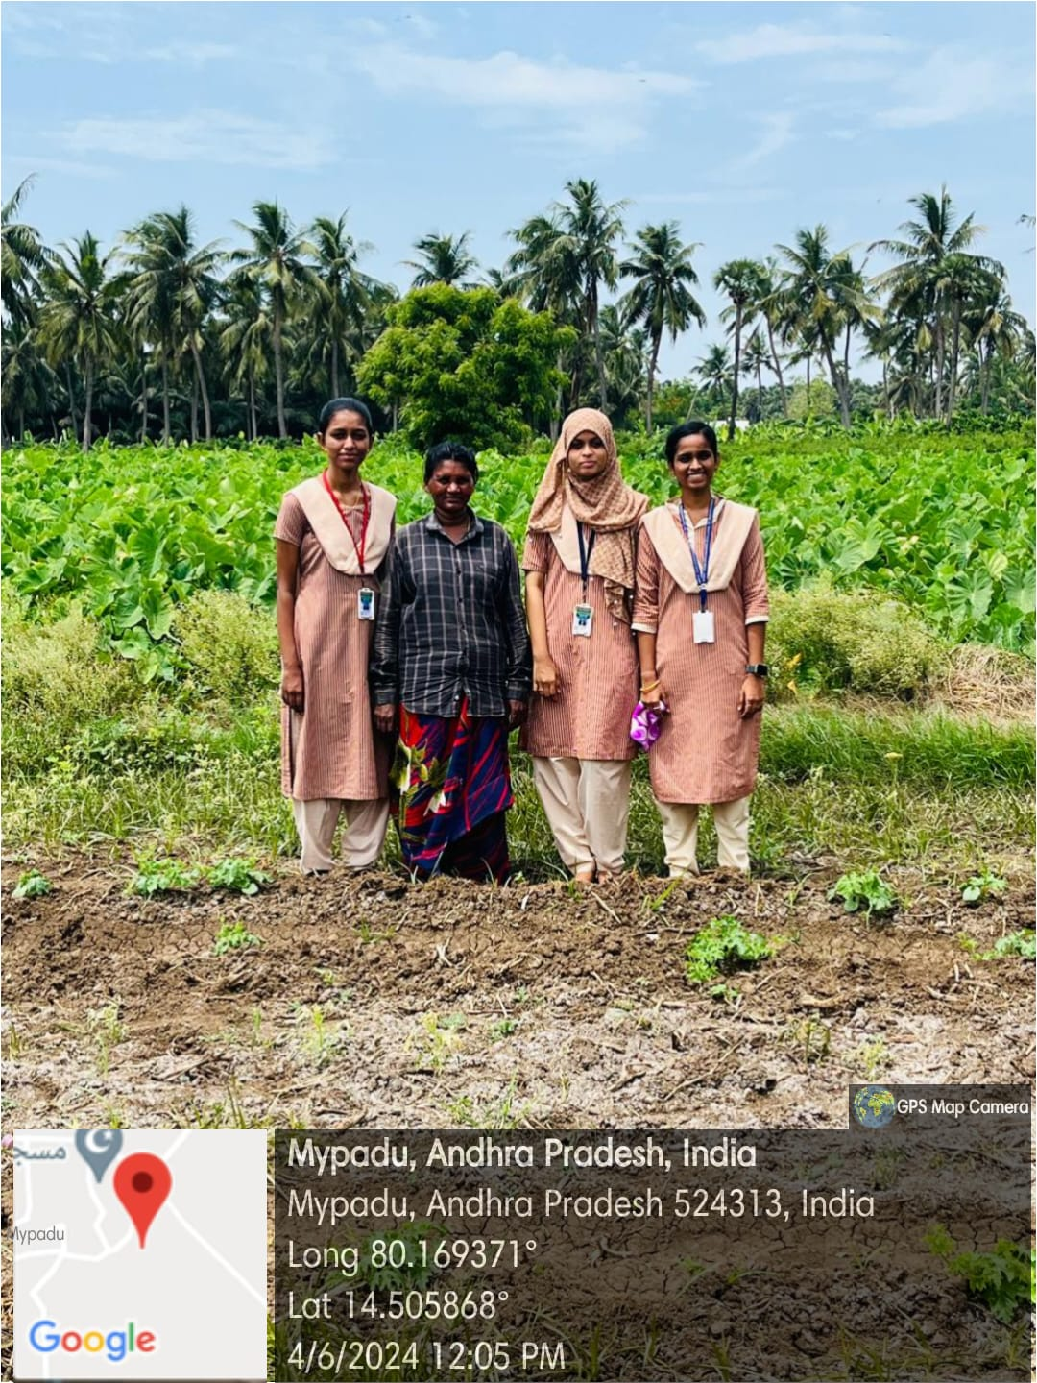

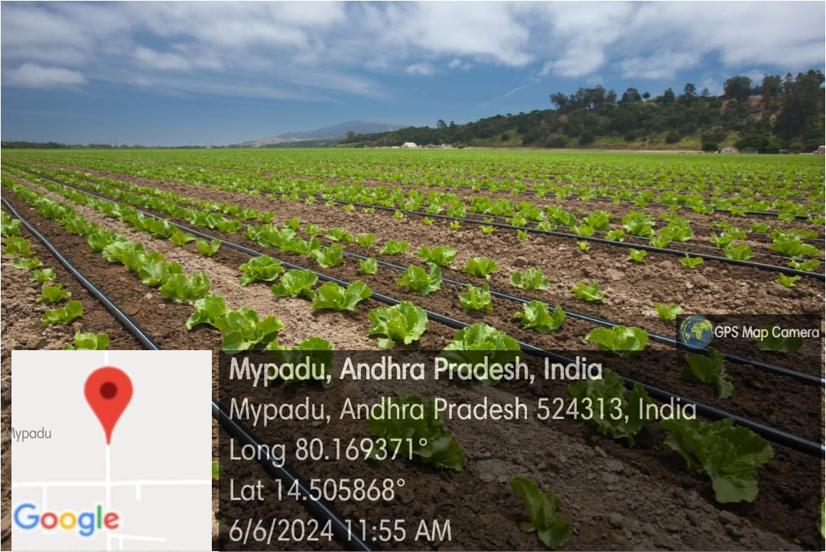

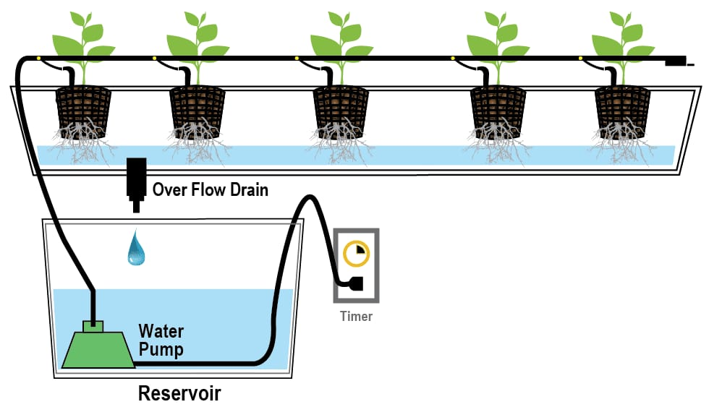

***Drip irrigation system***

**ACTIVITY LOG FOR FIFTH WEEK**

|  |  |  |  |
| --- | --- | --- | --- |
| **DAY &**  **DATE** | **BRIEF DESCRIPTION OF THE DAILY ACTIVITY** | **LEARNING OUTCOME** | **Person In-charge Signature** |
| Day-1 | Introduction to Sprinkle irrigation | An **i**rrigation sprinkler (also known as a water sprinkler or simply a sprinkler) is a device used to irrigate (water) agricultural crops, lawns, landscapes, golf courses, and other areas. |  |
| Day-2 | Types of Sprinkle irrigation | >Portable sprinkler irrigation  >Solid set and permanent sprinkler irrigation  >Side roll sprinkler irrigation  >Wheel line sprinkler irrigation |  |
| Day-3 | What are the advantages of using Sprinkle irrigation? | - Less infestation of pests and  Diseases.  -Reduced water usage and labor costs.  -Increase in crop yields and healthy growth of crops. |  |
| Day-4 | What are the disadvantages of Sprinkle irrigation? | >High operating cost  >Water will drift when there is a lot of wind  >A stable water supply is needed  >Saline water may cause problem |  |
| Day-5 | What types of crops are best suited for Sprinkle irrigation? | >Vegetables such as potatoes, corn, soyabeans  >Grains such as wheat, oats  >Fruits such as grapes, citrus fruits, stone fruits |  |
| Day-6 | How much time they use electricity for Sprinkle irrigation? | On average, a sprinkler system uses around **1,200 watts per hour.** |  |

**WEEKLY REPORT**

**Week-5 (From dt: 10-06-2024 to dt: 15-06-2024)**

|  |
| --- |
| **Objective of the Activity Done: Utilization of free electricity to farmers and related issues***.* |
| **Detailed Report:** |
| On day-1:   * On this day of our survey, we also observed another type of irrigation method called “Sprinkle irrigation”. * It is a water sprinkler device used to irrigate landscapes, crops through pipes and sprinklers. * Water is pumped through the pipes and distributed by the sprinklers over the irrigation area. |
| On day-2:   * We surveyed about the types of sprinkle irrigation used in different conditions. * Centre pivot for large scale agriculture, micro sprinkler for small areas, and lateral pivot for rectangular areas. |
| On day-3:   * The advantages we came to know are water is uniformly distributed, flexibility in soil, and saves more time and labour cost. * Due to these advantages in further this system may increase more and reduce manual working. |
| On day-4:   * Including advantages also there are disadvantages using this system. * There is water loss, high cost for installation and maintenance, and large energy consumption is required. |
| On day-5:   * We observed the crops grown under this system and started surveying about the crops grown. * They grow cereals like wheat, vegetables like carrots, and others. |
| On day-6:   * At last we asked them about how much electricity is used for this system. * Based on the size of the area the usage of electricity is required. * On average it consumes 1200 watts per hour and it runs averagely 30-60 min per zone. |

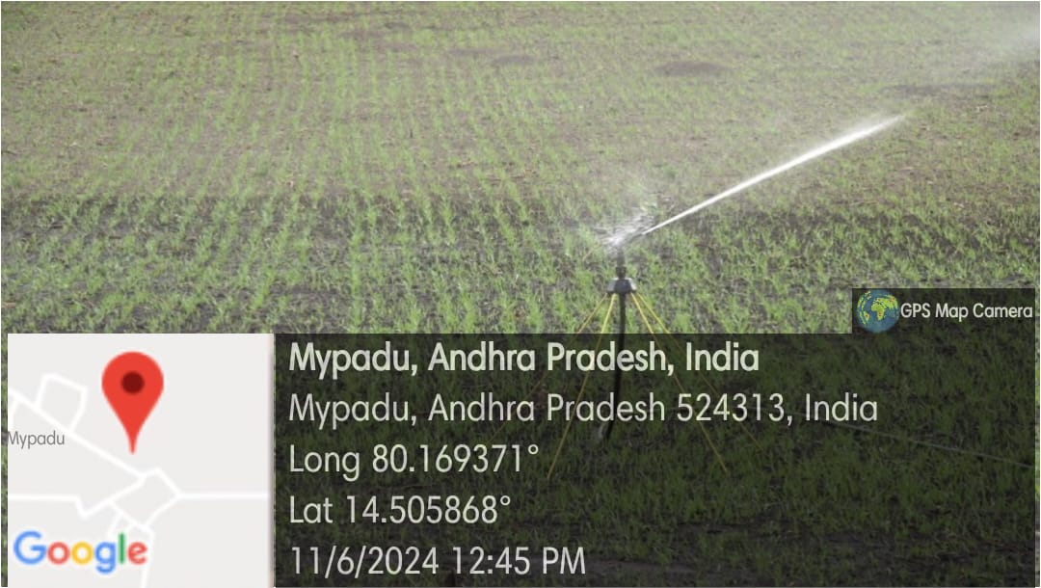

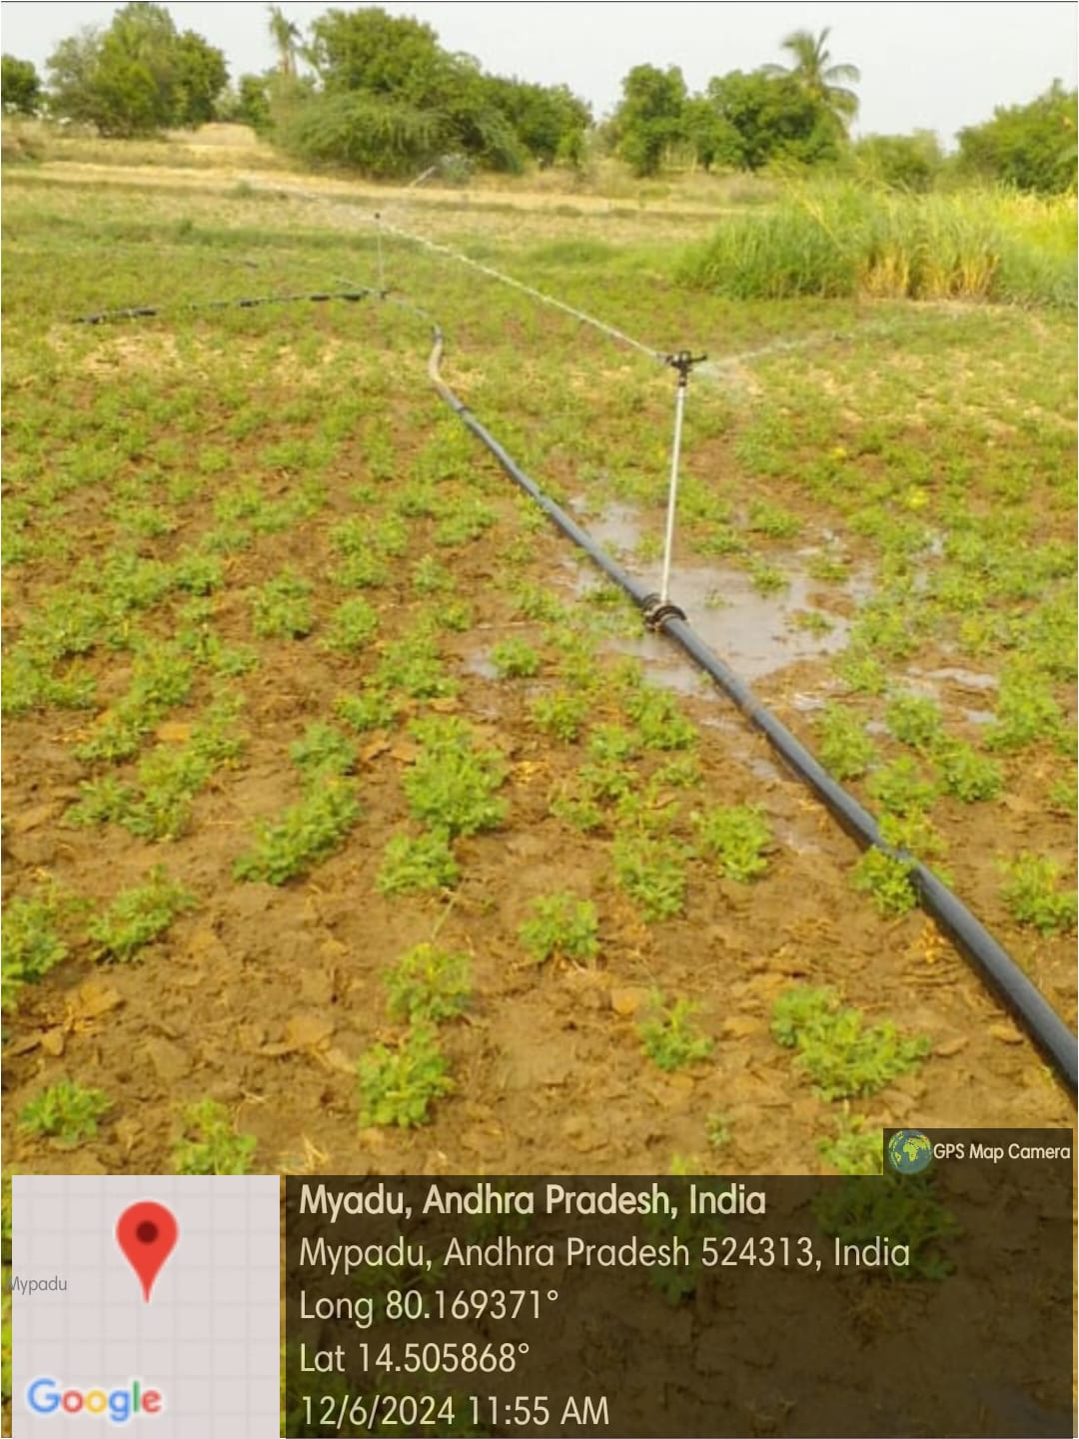

**ACTIVITY LOG FOR SIXTH WEEK**

|  |  |  |  |
| --- | --- | --- | --- |
| **DAY**  **& DATE** | **BRIEF DESCRIPTION OF THE DAILY ACTIVITY** | **LEARNING OUTCOME** | **Person In-charge Signature** |
| Day-1 | How essential is electricity to farming activities? | Electricity plays a key role in the agricultural sector as it is used for powering a wide range of equipment and systems that facilitate production. Electric pumps are used to supply the water for irrigation and lighting for the crops. |  |
| Day-2 | Who started giving free electricity to farmers in India and Andhra Pradesh? | In India, Prime minister Narendra Modi started giving free electricity to farmers on February 15,2024.  In AP, Dr. Y. S. Rajashekhar Reddy started giving free electricity to farmers. |  |
| Day-3 | Which irrigation is best in between Drip and sprinkle irrigation? Which consumers less electricity in between them? | Between drip irrigation and sprinkler irrigation, the choice depends on various factors including crop type, soil type, climate, and water availability. However, regarding electricity consumption, drip irrigation generally consumes less electricity compared to sprinkler irrigation |  |
| Day-4 | How much electricity a farmer consumes per a day in India? | On average, an Indian village has a total electricity demand of approximately 1,826 kWh per day. |  |
| Day-5 | What is the average electricity bill in farming per day? | On an average a farmer gets 210 rupees as an electricity bill per day. |  |
| Day-6 | What will be the impact on villages if there is no electricity? | The impact on villages without electricity can be significant and wide-ranging, affecting various aspects of daily life and development: such as Quality of life, Education, Economic development, connection and connectivity etc |  |

**WEEKLY REPORT**

**Week-6 (From DT: 17-06-2024 to DT: 22-06-2024)**

|  |
| --- |
| **Objective of the Activity Done: Utilization of free electricity to farmers and related issues***.* |
| **Detailed Report:** |
| On day-1:   * After surveying all about sources of electricity used by farmers, this day we surveyed about how electricity is essential to farmers, and who started this scheme, etc. * We understood that electricity plays a key role and widely used. * Mostly water motors are used more under electricity usage. |
| On day-2:   * During our survey we wanted to know how, when and by whom this scheme was started. * We came to know that, in India Prime minister Narendra Modi started giving free electricity to farmers on February 15, 2024. * In AP, Dr. Y. S. Rajashekhar Reddy started giving free electricity to farmers. |
| On day-3:   * Regarding the usage of electricity we compared the use of electricity in drip and sprinkle irrigations. * Both are used based on the fertility of land, crops, and water availability. * While during electricity drip consumes less electricity compared to sprinkle irrigation. |
| On day-4:   * We gathered overall usage of electricity in India through online. * An Indian village has a total electricity demand of approximately 1,826 kWh per day. * In Andhra Pradesh they consume averagely 17,905 MW. |
| On day-5:   * We researched on how much electricity bill farmers get per day for irrigation. * On an average a farmer gets 210 rupees as an electricity bill per day. |
| On day-6:   * We ourselves questioned, what if there will be no electricity for farming. * Electricity in farming developed the amount of crops, save time and make connectivity outside world. * At final we completed this week report and submitted it to our respected guide. |

